**Schematic Reading Notes:**

You’ll encounter three types of diagrams in electricity and electronics: block, schematic, and pictorial.

A block diagram gives you an overview of how the discrete circuits within a device or system interact.

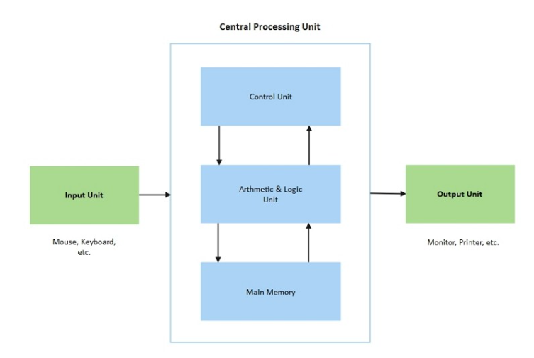

Schematic diagram: a simplified drawing showing how components are connected in a system, using symbols and lines to help design, build, and troubleshoot.

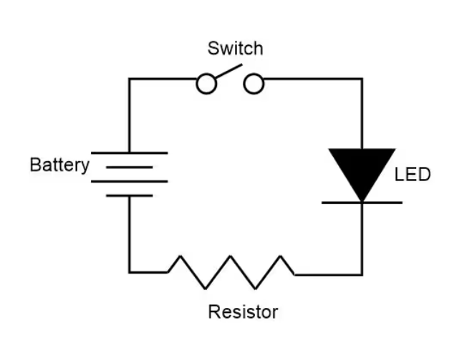

A pictorial diagram, sometimes called a layout diagram, shows the actual physical arrangement of the circuit elements on the circuit board or chassis, so that you can quickly find and identify components to test or replace.

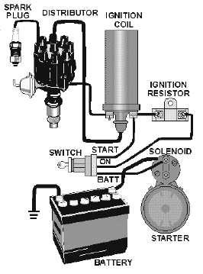

When you troubleshoot an unfamiliar electronic circuit, you’ll usually start with the block diagram to find where the trouble originates. Then you’ll refer to the schematic diagram (or part of it) to find the faulty component in relation to other components in the circuit. A pictorial diagram can then tell you where the faulty component physically resides, so that you can test it and, if necessary, replace it.

In a block diagram, each block represents all of the schematic symbols related to that part of the circuit. In addition, each block has a label that describes or names the circuit it represents. However, the block does nothing to explain the actual makeup of the circuit it represents.

A block diagram can provide a clear understanding of how each part operates in conjunction with the others.

A schematic diagram acts, in effect, as a map of an electronic circuit, showing all of the individual components and how they interconnect with one another.

A schematic drawing must indicate not only all components necessary to make a specific scheme, but also how these components interrelate to one another.

A schematic diagram reveals the scheme of a system by means of symbology. Symbology in schematic diagrams refers to the use of standardized symbols, icons, and graphics to represent components, devices, and concepts in a clear, consistent, and efficient visual representation of a system or process.

Inconsistencies arise in schematic symbology, and that’s a situation that makes electronics-related diagrams more sophisticated than road maps.

By knowing the type of component alone, you can’t tell what role it plays in a circuit until you have a good schematic diagram showing all the components in the circuit, and how they all interconnect. Rarely can you get all this information in easy-to-read form by examining the physical hardware.

Hard-wiring: the physical components and interconnections of a circuit.

A schematic diagram gives you an overall picture of a circuit and shows you how the various routes and components interact with other routes and components. When you can see how the overall circuit depends on each individual circuit leg and component, you can diagnose and repair the problem.

Our senses along with our central processor, the brain, render us less than proficient at mentally conceiving all of the workings of electronic circuits by dealing with them directly. Therefore, we have to accept data a small step at a time, compiling it in hardcopy form (through symbology) and providing hardcopy readout.

Schematic symbols and diagrams are designed for human beings, so human logic constitutes a prime factor in determining which symbols mean what.

Schematic diagrams are encoded representations of circuits, while pictorials show us the physical objects, often proportioned according to their relative size, and sometimes rendered so as to look three-dimensional by means of shading and perspective. Schematic diagrams depict circuit components as symbols only, without regard to their real-world size or shape, and in two dimensions, completely lacking depth or perspective.

A block diagram portrays the general construction of an electronic device or system. A block diagram can also provide a simplified version of a circuit by separating the main parts and showing you how they are interconnected.

In sequence going from left to right, the electricity passes through the transformer, the rectifier, and the filter before arriving at the output as DC. In this case, the lines that connect the blocks do not have arrows because readers will naturally assume that the flow goes from left to right. In more complicated block diagrams, the interconnecting lines may include arrows to show which block affects which, or to indicate the general direction of signal flow when it might not otherwise be clear.

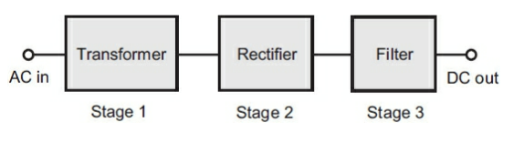

Block diagrams can also be called functional diagrams because they reveal the basic functioning of the electronic circuit.

Block diagrams may constitute the beginning design for a circuit. The next step would be to develop it into a schematic diagram by putting in the circuits that fill in each block.

At the same time, a schematic diagram may mark the beginning of a circuit design. But in this case, you have the detail without knowing the overall flow of the design, so someone would have to work backward to come up with the block diagram demonstrating how operation happens.

If presented without accompanying schematics, a block diagram describes the basic functional operation of an electronic device or system. The block diagram can prove most useful when you don’t need to know the functions of individual components.

When we need to know, or portray, individual differences between circuits that do essentially the same things, then we need schematic diagrams.

In the below block diagram, the flow of electricity is shown using arrows. They also usually tell the user the sequence of events or direction of signal flow.

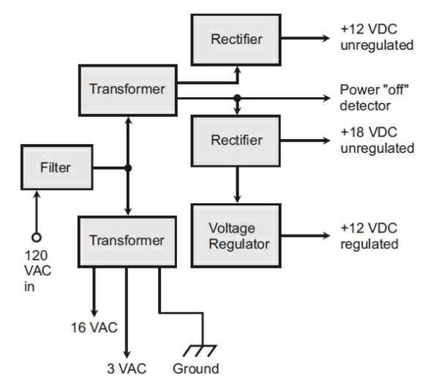

More sophisticated block diagrams also include triangles to represent circuit blocks built around specialized amplifiers constructed within integrated circuits (ICs), also known as chips.

Block diagrams can describe the functioning of electronic circuits, but in the world of computers, another form of diagramming is sometimes used to portray the functioning of a program. This system is a flowchart. A flowchart provides a graphic representation of the logical paths that a computer will take as it executes a particular program.

For complex problems, a formal written specification might be necessary to ensure that everyone involved understands and agrees on what the problem is, and on what the results of the program should be.

When the flow of control is complicated by many different paths that result from many decisions, a good flowchart can help the programmer sort things out. The flowchart can serve as a thinking-out tool to understand the problem and to aid in program design.

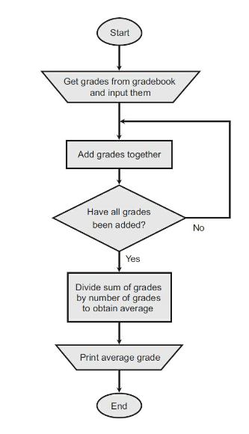

In order to promote uniformity in flowcharts, standard symbols have been adopted.

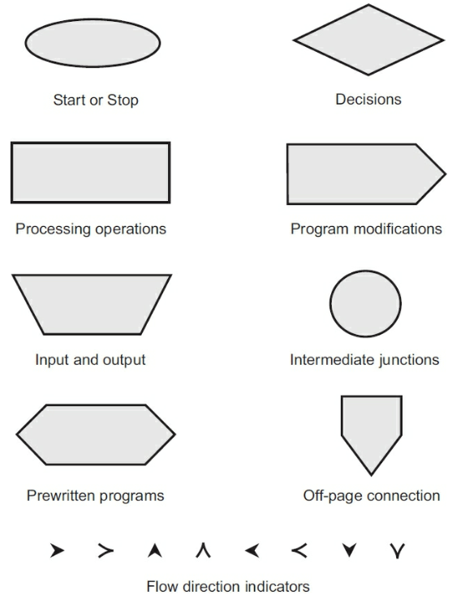

The normal direction of processes in a flowchart runs from top to bottom and from left to right, the same way as people read books in most of the world. Arrowheads on flow lines indicate direction. The arrows can be omitted if, but only if, the direction of flow is obvious without them.

A small five-sided box, which has the shape of the home plate on a baseball field, shows where one page of a flowchart connects to the next, if the entire flowchart has more than one page. The intermediate junction and off-page connection points are labeled with numbers and letters to let readers know that all like symbols with the same character inside are meant to be connected together.

From a purely electronic standpoint, functional diagrams abound and are usually more numerous than the schematic diagrams in the computer world.

With schematic drawings, symbols indicate conductors, resistors, capacitors, solid-state components, and other electronic parts. Every time a new component comes out, a new schematic symbol is derived for it. Often, a new type of component is a modification of one that already exists, so the new schematic symbol ends up as a modification of the symbol for the preexisting component.

Resistors are among the simplest electronic components. As the term implies, they resist the flow of electrical current. The common symbol for a resistor is shown below.



The symbol below demonstrates an adaptation of a common symbol when a component is a variation of another. This symbol is for a two-terminal variable resistor. The arrow across means that this component can be adjusted upward.

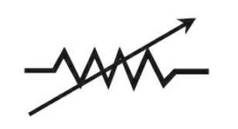

The symbol below is for a resistor that connects one end to the tap.

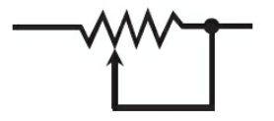

The symbol below is a resistor that uses a three-terminal arrangement.

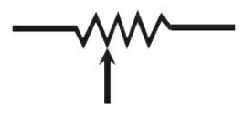

In schematic drawings, an arrow *often* indicates variable properties of a component, but not always! Transistors, diodes, and some other solid-state devices have arrows in their schematic symbols. These arrows don’t have anything to do with variable or adjustable properties. Arrows can also sometimes indicate the direction of current or signal flow in complex circuits.

The below symbol represents a variation of a typical resistor called a rotary potentiometer.

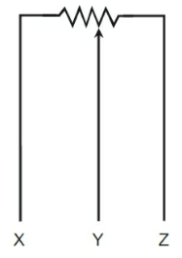

Capacitors are electronic components that have the ability to block direct current (DC), while passing alternating current (AC). The standard symbol for a capacitor is shown below.



Much like what has been shown for variations on resistors, the same can be said of capacitors. Below is the symbol for an air dielectric capacitor.



And this is the symbol for a solid dielectric capacitor.

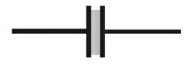

Horizontal lines connect to the centers of the vertical line and the parenthesis to indicate the component leads. The parenthesis side of a capacitor indicates the lead that should go to electrical ground, or to the circuit point more nearly connected to electrical ground.

Below is the schematic symbol for a polarized or electrolytic capacitor. Notice that this symbol is the same as the one for the nonpolarized component, but a plus (+) sign has been added to one side. This sign indicates that the positive terminal of the component goes to the external circuitry. Occasionally, a negative (–) symbol will also appear on the opposite side.

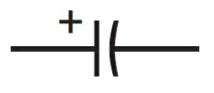

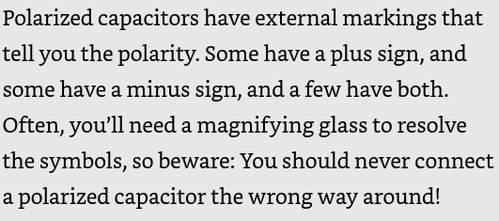

Arrowed lines that run diagonally across a symbol usually denotes variability (the ability to change capacitance value).

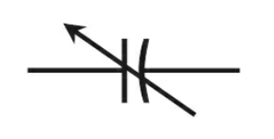

The other two ways that you may see a variable capacitor are shown below. Note: the above symbol is considered the standard. Probably the best takeaway is that there will be some kind of arrow notation.

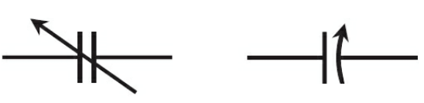

Sometimes, two separate variable capacitors are connected together or ganged in a circuit. In a ganged arrangement, two or more units are used to control two or more electronic circuits, but both components are varied simultaneously by tying the rotors of the two units together.

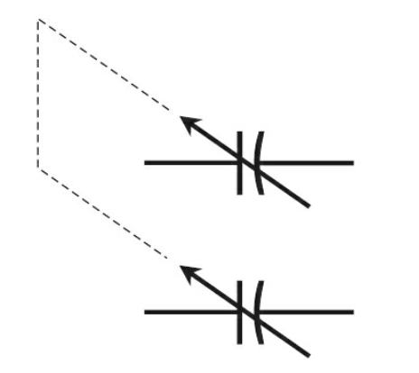

An air-core inductor is a type of inductor that uses air as its core material, rather than a magnetic material like iron or ferrite. This means that it doesn't use a magnetic core to increase its inductance, but instead relies on the air surrounding the coil to store energy. The symbol for this component is shown below.



A tapped arrangement allows for the selection of an input or output point that offers lower inductance than the full coil does.

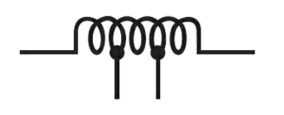

Much like a variable capacitor, a variable inductor is indicated by an arrow going through it. Either one of the two bottom symbols can be used to indicate this.

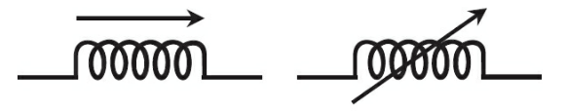

When an iron core is added to an inductor, it becomes stronger. Both symbols below are what you may see when a solid or laminated iron core inductor. Look for the two bars to recognize this component.

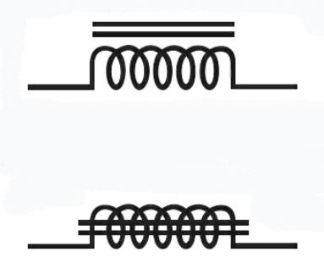

A tapped coil inductor with a solid or laminated core will have the two bottom prongs like a tapped inductor, while an arrow going through will mean the component is a variable solid or laminated core inductor like a regular variable inductor symbol.

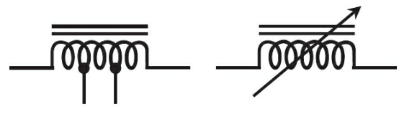

At higher frequencies, solid-iron and laminated-iron cores aren’t efficient enough to function in inductors. Engineers would say that they have too much loss. Special core is needed if you want to increase the inductance over what you can get with nonferromagnetic core materials, such as air, plastic, ceramic, or wood. A physically- solid sample called a powdered-iron core is often used. The symbols below demonstrate how this looks: almost identical to a solid or laminated core, but with broken up lines. These types of components, like all other types of inductors, can be tapped or continuously variable.

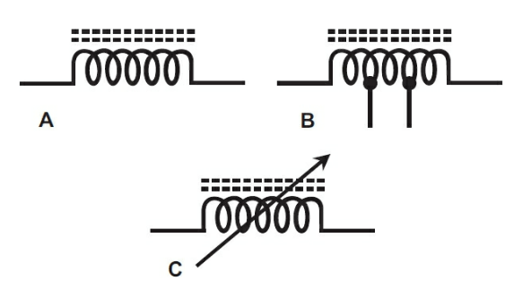

A transformer is made up of multiple inductors with the coil turns interspersed or wound around different parts of a single core.

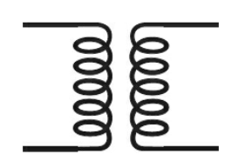

These can also come with iron cores:

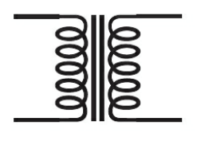

Cores and taps:

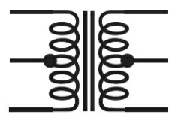

With a powdered-iron core:

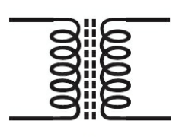

And as an adjustable, with powdered-iron core:

